# Pediatric – Lower Extremity Gait System: A Control and Actuators Perspective

Sri Ranga Prasad Maddi 1§*, Sagar Shivaram1*, Sai Tadimeti1*, Fangshi Zhu1*

1Department of Electrical Engineering, Cullen College Of Engineering, University Of Houston, Houston, Texas, US

*These authors contributed equally to this work

§Corresponding author

Email addresses:

SRPM: [smaddi@uh.edu](mailto:smaddi@uh.edu)

SS: [smshivaram@uh.edu](mailto:smshivaram@uh.edu)

ST: [sktadimeti@uh.edu](mailto:sktadimeti@uh.edu)

FZ: [fzhu@uh.edu](mailto:fzhu@uh.edu)

# Abstract

## Background

Recent technological developments in powered robotics exoskeletons create powerful adjunctive tools for rehabilitation and accelerate functional recovery for spinal cord injury (SCI), traumatic brain injury (TBI) and cerebral palsy (CP) survivors. However, despite the fact that different advanced power exoskeleton systems has been developed for adult rehabilitation, there is no such system designed yet for the pediatric population who accounts for a large portion of the whole SCI/TBI/CP group. In this study, we will design an adjustable light-weight powered lower limb exoskeleton system for gait rehabilition targeting children between 4-8 years old who suffer from post SCI/TBI/CP gait disorder. Here in this paper we present the design of an active control actuator and feedback sensor system for this pediatric exoskeleton.

## Methods

Two main criterions were considered for actuators selection. First, thorough calculations and evaluations of children joints’ torque, angle position and velocity profile were conducted to make sure the motor and gear we chose will provide enough assistance; Second, aesthetic factors such as compactness, lightweight and noiselessness which would make the child rehabilitation pyschologically more effective were also taken into consideration. By using the selected motors and gears, we constructed a single leg prototype with 3 active actuation joints at hip, knee and ankle respectively. Gait kinematics were formatted and programmed on the microcontroller to drive the actuator mechanism to replicate the standard healthy gait pattern. For the feedback loop, potentiometer sensors and pressure sensors were chosen to measure the joint angle positions and the foot contacting forces. The kinematics data collected from the potentiometers and footswitch sensors were sent back to microcroller and PC in real time for clinical monitoring and offline data storage.

## Results

By comparing the desired gait torques, angle position and velocity profile with what motors, gears could provide, Maxon BLDC Motor 397172, Harmonic Gear CSD-20-160-2A and 4Q Servo Control drive ESCON 36/3 #414533 were finally selected for the pediatric exoskelton actuator system. Also, for backup and proof of concept purposed, another TowerPro SG90 Mini Servo system were selected for the small single leg prototype we built. The forward control test on the small prototype indicates the gait pattern programmed on the microcontroller was reliably replicated and the real time data monitoring system was able to relay data off the sensors.

## Conclusions

The designed sensor and actuator system will fulfil the primary control system need for the pediatric exoskeleton with augmented EMG for intent detection.

## Keywords

Pediatric, gait rehabilitation, powered exoskeleton, actuator, sensor, position control, kinematics data monitoring

# Background

## Significance

Spinal cord injury (SCI), traumatic brain injury (TBI), and cerebral palsy (CP) are major determinants of gait disability in children [1]. There are approximately 250,000 cases of SCI each year with over 12,000 occurring in the United States. Pediatric SCI cases account for approximately 480 of the annual incidences. In the United States, CP affects about 2-3 children per 1,000, with as many as 1,000,000 people of all ages affected. The average lifetime costs for an individual, directly attributable to lower limb paralysis (complete and incomplete paraplegia), can reach $1-2.3 million and approximately $1 million for individuals with CP. Decreased mobility is also associated with shorter life expectancy, social stigma, and increased rates of depression [2].

Emergent robotic technologies for gait restoration and rehabilitation hold great potential to restore gait functions to patients with paraplegia and stroke [3][4]. Compared to traditional therapy, which involves physically guiding the patient’s leg to reinforce normal walking gait, new therapies that employ powered assistance from robot devices, like robotic exoskeletons, provide an economical and less labor-demanding solution to deliver consistent and repetitive motor practice to patients, and therefore getting increasing popular.

Compared to adult patients, pediatric population has the greatest potential for recovery both biomechanically and neurally due to greater neuroplasticity and cognitive-motor development in the first decade of life. However, unfortunately, current powered exoskeleton devices are only developed for adults rather than for children, who also account for a large portion of the whole SCI/TBI/CP group. Though several advanced system has been developed for adult and proved to be effective through clinical trial in context of gait rehabilitaiton, developing a pediatric exoskeleton skeleton is quite challenging due to the fact that children included in the population range grow very fast. No two children have the same characteristics of injury or physiology.

## Team Focus (Acutators) – Review and our advantage

So as one of the core part of the powered exoskeleton systems design, proper selection and designing of actuation mechanism that integrates higher flexibility in terms of speeds and torques and customizability to every individual child is a highly challenging task. The actuator mechanism must also conform to other critical factors such as compactness, light weight, noiselessness etc. Given these criterion, most type of actuators used in robotics cannot be used in exoskeletons. Linear hydraulic and pneumatic actuators normally have high power density, but they are usually bulky and present problems of internal leakage and friction [5]. SEAs have been used in some rehabilitation devices [6], but they still face a common limitation about the spring constant of the elastic element that fixed. The harmonious coordination of force and position between patient and exoskeleton is difficult between different subjects [7]. So proper selection of actuator system that could ensure power consumption efficiency, ease of maintenance and actuation, compactness, portability, mobility, high torque assistance and high speed at the same time would be vital to develop the pediatric exoskeleton system. The only motor that could meet all these criterion is brushless DC electric motor. In order to attain a controlled gait pattern we need to have a complete control on motors rotation per minute (rpm, related to trajectory) and current (related to torque). Servo motors were selected because of their reliability. Considering the practical availability of DC servos at nominal torque ratings of 13 Nm we designed a servo mechanism with a DC motor and gear combination.

Many useful sensors are being integrated into exoskeletons to provide necessary feedbacks which ensures reliability and safety and complete the dynamic close loop control. The interaction torque measuring sensors on the H2 are state of the art. They give critical information related to actuator coupling with the actual joint. The ekso bionics exoskeleton has sensors to detect weight shift during gait cycle. Such sensors plays an important role in ascertain the therapy is safe and effective. Indego system has pressure sensors to determine the intent to walk or sit. EMG sensors are being used to detect intent of motion in current research. In our design, we implemented a forward postion control mechanism and develop a real time feedback kinematics monitoring system so foot force sensing resistors (FSR) and potentiometers were chosen and integrated to detect the gait phase and obtain the joint angle position in real time.

## Research Aim & Goal

The overall goal of this study is to design and develop and light-weight powered lower limb exoskeleton system for gait rehablitaion for children between 4-8 years old who suffer from post SCI/TBI/CP gait disfunction. The team goal we present here will focus on the design of an active control actuator and feedback sensor system for this pediatric exoskeleton.

# Methods

## Actuator System Selection

### Motor Selection

Selection of motor in a particular model is mainly depend torque and rpm (shown in Fig. 1) where torque defines the power required at specific rpm, which is defined by equation (1):

$Power\left(w\right)=\frac{Torque\left(Nm\right)*Speed \left(rpm\right)}{9.5488}$ (1)

From the linear analysis of torque profiles [8][9][10][11] and gait profiles [12]we found the nominal torque required is 13Nm for 4-8 years old weighing[13]12.5 kg-35.5 kg with a gait time 1.45 Second, where Gait time = Stride × Velocity[14].

Analyzing the gait profiles, RPM, Nominal Torque required (shown in Fig.1 and Table 2), we can decide on power of motor and gear combination needed.

From the Table 3 we can clearly conclude that we have selected a motor with 70W power rating, but we cannot operate a motor at such low rpm with such a high torque requirements. There should be a balance between voltage and current where Power(rpm) = Voltage(V) × Current(I). The voltage applied is directly proportional to speed of motor and Current applied is directly proportional to torque.

### Gear Selection

Selection of gear involves nominal output torque needed and gear ratio required. The nominal output torque is 13Nm. The gear ratio can be determined by input speed applied and output speed required. From the operating curves we can determine the maximum efficiency points are at 6000 rpm and output speed required at design point is 30 rpm. Therefore the gear ratio required is 200:1. However, due to practical availability limitations of such gear ratio with required compactness and weight we modified our design to operate at 5000 rpm which needs a gear ratio of 160:1, considering the speed curve is in optimal state even at this point.

### Drive Selection

The Selection of electrical drive to drive the Maxon motor depends on motor controlling strategy. For the purpose of complete control of the motors, we need to operate the motor in 4 quadrants, i.e., control its position in both clock and anticlockwise direction. Also the drive which we select should match the electrical rating of the motor we selected.

## Feedback Sensor Selection

### Position Encoder

To detect position of the joint a potentiometer (POT) is used in this project, POT has to be attached to the exoskeleton in coherence with the motors. As the motor rotates, the shaft of the POT rotates and varies the resistance across the POT thus the analog value read by the Arduino changes in accordance with the angle rotated. The relationship between the shaft rotation and analog values is liner and can be mapped to a range of 180 degrees (shown in table). We can calculate the angular rotation of the POT using equation (2):

$x=\frac{Analog value*180}{1024}$ (2)

Since we have negative angles we will have to set an offset of 10 degrees (e.g.: the 7 degrees will be offset to 17 degrees). The POT’s used are capable of handling a voltage of 150V and the output values does not vary in the operating temperature.

### Pressure sensor and footswitch

Pressure sensors were integrated to detect the gait phase. The operating principle of FSR sensor is the variation of resistance with respect to the pressure applied to it, which will affects the analog value of output voltage. By observing the output of the sensor while applying standard weight on the FSR, we are able to map the analog voltage output to the forces applied on the sensors and then a threshold sets could be determined to detect the different gait phase. In this design, we implemented the heel strike and toe off detection by putting two FSR on the heel and toe position on the footplate as shown in Fig. 2.

## High level Control

### Microcontroller selection

Arduino YUN was chosen as the microcontroller for the prototype. Ardiuno has capabilities which can not only fullfill our current objectives but also allows for future extensions such as operation via WiFi and provision for adding more sensors. This is due to the fact that YUN has an on-board WiFi module and 12 analog input pins out of which we are using only 5. YUN also has a micro SD slot for storage, this saves additional hardware such as shields which has to be integrated for this feature. It has a provision to communicate via I2C, SPI and Serial protocols.

### Control system and feedback loop

As shown in the Fig.3 , with the Arduino at the heart of our system, we integrated the sensors and ports for communication. The potentiometers are attached in coherence with motor shaft so as to detect angular position of the joint during actuation. The footplate of the exoskeleton has grooves at the toe and the heel to accommodate footswitch sensors. The sensor data is both sent back to MATLAB for real time visualization and store in on board SD card for offline analysis. Provision is made for EMG signals to be accepted and sent to master controller. The master controller gets the angle values from Arduino through the Inter-Integrated Circuit (I2C) protocol to drive the actuators. The actuator system is made up of Motor, Gear and Drive which are located at each joint.

As shown in the Fig. 4, when the exoskeleton is switched on, the communication modules between controller, host PC (with MATLAB running) and the master controller (a controller which controls the motors) are initialized. Depending on if we are programming new values or replicating an already existing gait pattern, there is a deviation in the flow. If new values are programmed, a serial port opens up and the values will be sent to Arduino by MATLAB through serial port. Real time kinematics data captured by the feedback sensors will be stored on a text file in the SD card. The values from sensors are read and manipulated as needed.

### Communication programming

A serial Communication has been established between Arduino Microcontroller and MATLAB during initializing stage of the program flow. Serial communication is used due to fast transmission speed and low package loss rate. In this design, both devices on the serial bus are configured to use the same protocol and the ports baud rate were configured to 9600 bits-per-second (bps) to ensure the fast data transmission.

Between Arduino and embeded master controller (implemented by embeded team), a more reliable I2C protocol communication has been established. Compared to serial commnucation when the master and arduino are near to each other, I2C is good for high data rate full-duplex (simultaneous sending and receiving of data) connections, supporting clock rates upwards of 10MHz where in our arduino YUN has a clock of 16Mhz. The hardware at either end is usually a very simple shift register, allowing easy implementation in software.

## Command Formatting and Feedback Data Reading

Serial Communication between Arduino and MATLAB is successfully configured, the controlling commands are formatted according to byte order shown in Table 5.

Each Sensor would have its identification number, once the package is received the sensor identification number is verified and the corresponding data is fetched, analysed and displayed in an understandable format.

# Results

## Actuator Selection

### Motor Selection

Based on these parameters we have selected Maxon BLDC Motor 397172 where the operating curves (shown in Fig. 5) and technical specificaitons (shown in Fig. 6) matched the requirement.

### Gear Selection

By checking the combination of torque range and gear ratio, we have selected Harmonic Gear drive CSD-20-160-2A to meet the desired parameters. The results could be seen from the Figure 7.

### Drive Selection

Based on the electrical ratings of the motor we selected, we checked all the 4 quadrants drives that were available. Also considering the limitations introduced by the CAN bus control required by the drives, we finally decided to choose a 4Q servo control drive from Maxon which is ESCON 36/3 #414533 that can be easily controlled by PWM signal from Microcontroller.

## Feedback sensors selection

### Position Encoder

All the aforementioned requirements were satisfied by POT’s supplied by Rotary Potentiometer - 10k Ohm, Linear which costs around $1 each so we use this POT for real time angle position monitoring.

### Pressure Sensor and footswitch

The pressure sensors selected for the project are Flexiforce Pressure Sensor - 100lbs that are capable of measuring up to 100lbs without additional resistance. The output values does not change for temperature variations in the operating rang of 15F to 150F. In our case we decided upon the threshold value of 40 (analog value) which is obtained by applying a weight of 35 Kgs (77 lbs), which should be reset for each patient. When the analog value is above threshold point we can confirm the heel strike phase of gait. When the values drop below 40 we can check for toe off phase.

## Small motors Controlling results

By mounting three TowerPro 9G DC servo motors SG 90 on a 3 segments light-weight plastic model, we were able to integrate all the parts together and imitate a scaled down version of right leg exoskeleton prototype to show the proof of concept. Fully formatted right leg trajectories were replicated for 10 gait cycles to configure a pesudo continuous walking command set and uploaded to the microcontroller to drive three actuators to follow the correct gait pattern. Fig. 8 gives the results from one step cycle. 10 equally-spaced frames were taken form one step cycle. As you can see, the all three joints followed the right trajetorys and coordinated very well. Combined together, they were able to drive the 3 segments to replicate the basic profile of the right leg walking pattern.

During the forward position control, the recording from the feedback sensors (potentiometer and FSR) were also collected and parallel sent back to host PC. To track the changes dynamically, a visulization interface were designed to monitor the kinematics changes in real time. As you can see from Fig. 9, all the feedback sensor data (angle position from right hip, right knee and right ankle, plus binaried foot pressure/footswitch from right heel and right toe) were real time updating in a individual subplot. As shown in the figure, when experimenter manually rotates the potentiometers and press the FSR sensors, the corresponding channel will change very fast automaticly, which suggests the interface we designed could be used for fast clinical monitoring and later on close loop control.

## Maxon Speed Control Results

The control of the actuator is achieved by implementing closed loop speed control with a feedback from hall sensors which are built with motor and taking a position feedback from external potentiometer encoders. The drive feedback control strategy is shown in Fig 10 and Fig 11.

A dynamic feedback from the motor drive and external potentiometer encoder helps to determine the current position of the actuator which can further be controlled by providing necessary digital and PWM signals.

# Discussion

Here we present the development of the first powered lower limb pediatric exoskeleton system. By proper selection of the actuator system, feeback sensors, microcontroller and smart programing of the forward position control and feedback kinematics data collection loop, we designed the electrical control system for the pediatric exoskeleton system. The test on the scaled down single leg prototype showed that the controlling mechanism we designed in this project could successfully drive the exoskeleton to replicate the standard children gait trajectory. The speed control of Maxon motors also opens up the future possibility of programing the Maxon motor to follow the normal children gait pattern to provide robot assistance needed for children gait rehabilitaion.

However, it is important to notice a few limitaions does exist in this project. Due to limited time and unavailability of the harmonic gears, we were only able to show the proof of concept using a scaled down single leg prototype with small servo motors. Though the programming method are similar, gaps do exists between those small servo motors that we used and the large Maxon motors in context of torque range, controlling mechanism and power supply. So the next step would be implementing a two leg controlling strategy on real Maxon actuator system. Also, stain gauge sensors that measuring interaction torques between the robot and user could be incorporated in the system to build a more flexible, advanced and adaptive controlling strategy such as assisted as needed control.

# Conclusion

In summary, in this project, by thoroughly calcuating the torque and angle velocity range from healthy children kinematics, we successfully selected the motors, gears and microcontroller combiniation, and the feedback sensor needed to develop the lower limb pediactric exoskeleton. The test on the single leg prototype suggests the program we designed is able to implement a forward postion control, which opens the future possibility of developing more advance controlling stategy-based pediatric lower limb powered exoskeleton system.

# Competing interests

(Not applicable)

# Authors' contributions (Fangshi)

SRPM worked on the calculations and considerations to select the actuator mechanism. He also carried out PWM signals generation for the motors to test the proof of concept. SS handled the programming of the Arduino to achieve forward position control. He also worked on the implementation of feedback system implementation through selection of sensors and programming in collaboration with ST. ST worked on SD card data storage for offline data analysis and aided SS to make decisions on selection and calibration of sensors for feedback loop collection. FZ worked on MATLAB - Arduino communication and developing real time visualization interface for real-time data monitoring. He also involved with other team members as a source of knowledge of forward position control algorithm. All the authors were involved in the drafting, reading and approval this final manuscript.

# Acknowledgements

This project was supported and funded by the Laboratory of Brain-Machine Interface Systems, Cullen College of Engineering, University of Houston, Texas. Significant guidance and support was also received from Dr.Atilla Kilicarslan, Dr. Phat Luu and Manuel Cestari in decision of the actuator mechanism. We would also love to thank Marina Canela for providing valuable suggestions on placement of our sensors on the exoskeleton’s mechanical design.

# References

[1] “Cerebral Palsy – Topic Overview. WebMD.” [Online]. Available: Cerebral Palsy ? Topic Overview. WebMD. Available from http://www.webmd.com/ children/tc/cerebral-palsy-topic-overview.

[2] M. Oskoui, F. Coutinho, J. Dykeman, N. Jette, and T. Pringsheim, “An update on the prevalence of cerebral palsy: a systematic review and meta-analysis.,” *Dev. Med. Child Neurol.*, vol. 55, no. 6, pp. 509–519, Jun. 2013.

[3] P. Sale, M. Franceschini, A. Waldner, and S. Hesse, “Use of theSale, P., Franceschini, M., Waldner, A., & Hesse, S. (2012). Use of the robot assisted gait therapy in rehabilitation of patients with stroke and spinal cord injury. European Journal of Physical and Rehabilitation Medicine, 48(1), 111–121. robot,” *Eur. J. Phys. Rehabil. Med.*, vol. 48, no. 1, pp. 111–121, Mar. 2012.

[4] W. H. Chang and Y.-H. Kim, “Robot-assisted Therapy in Stroke Rehabilitation.,” *J. stroke*, vol. 15, no. 3, pp. 174–181, Sep. 2013.

[5] C. Sterling, E. Taub, D. Davis, T. Rickards, L. V Gauthier, A. Griffin, and G. Uswatte, “Structural neuroplastic change after constraint-induced movement therapy in children with cerebral palsy.,” *Pediatrics*, vol. 131, no. 5, pp. e1664–9, May 2013.

[6] E. E. Bleex, A. B. Zoss, H. Kazerooni, and A. Chu, “Biomechanical Design of the Berkeley Lower,” vol. 11, no. 2, pp. 128–138, 2006.

[7] J. A. N. Veneman, E. V. A. N. Asseldonk, R. Ekkelenkamp, and M. Buss, “Compliant Actuation of Rehabilitation Robots,” no. September, pp. 60–69, 2008.

[8] F. Epp, Y. Fan, and Y. Yin, “Active and Progressive Exoskeleton Rehabilitation Using Multisource Information Fusion From,” vol. 60, no. 12, pp. 3314–3321, 2013.

[9] J. S. Sulzer, K. E. Gordon, T. G. Hornby, M. a. Peshkin, and J. L. Patton, “Adaptation to knee flexion torque during gait,” *2009 IEEE Int. Conf. Rehabil. Robot.*, pp. 713–718, Jun. 2009.

[10] K. A. I.-I. Member, N. P. F.-I. Member, A. M. S.-I. Member, and L. J. H.-I. Member, “Contributions of Knee Swing Initiation and Ankle Plantar Flexion to the Walking Mechanics of Amputees using a Powered Prosthesis,” 2014.

[11] C. S. To, S. Member, R. Kobetic, J. R. Schnellenberger, M. L. Audu, and R. J. Triolo, “Design of a Variable Constraint Hip Mechanism for a Hybrid Neuroprosthesis to Restore Gait After Spinal Cord Injury,” vol. 13, no. 2, pp. 197–205, 2008.

[12] “CGA Normative Gait Database.” .

[13] “Center for Disease Control and Prevention.”

[14] D. Sutherland, R. Olshen, E. Biden, and M. Wyatt, *The Development of Mature Walking (Clinics in Developmental Medicine (Mac Keith Press))*. Mac Keith Press; Reprint edition (May 31, 1991).

# Figures

**Figure 1: Angle, velocity and acceleration profiles**

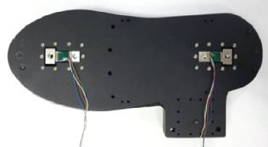

**Figure 2. FSR location on footplate for gait phase detection**

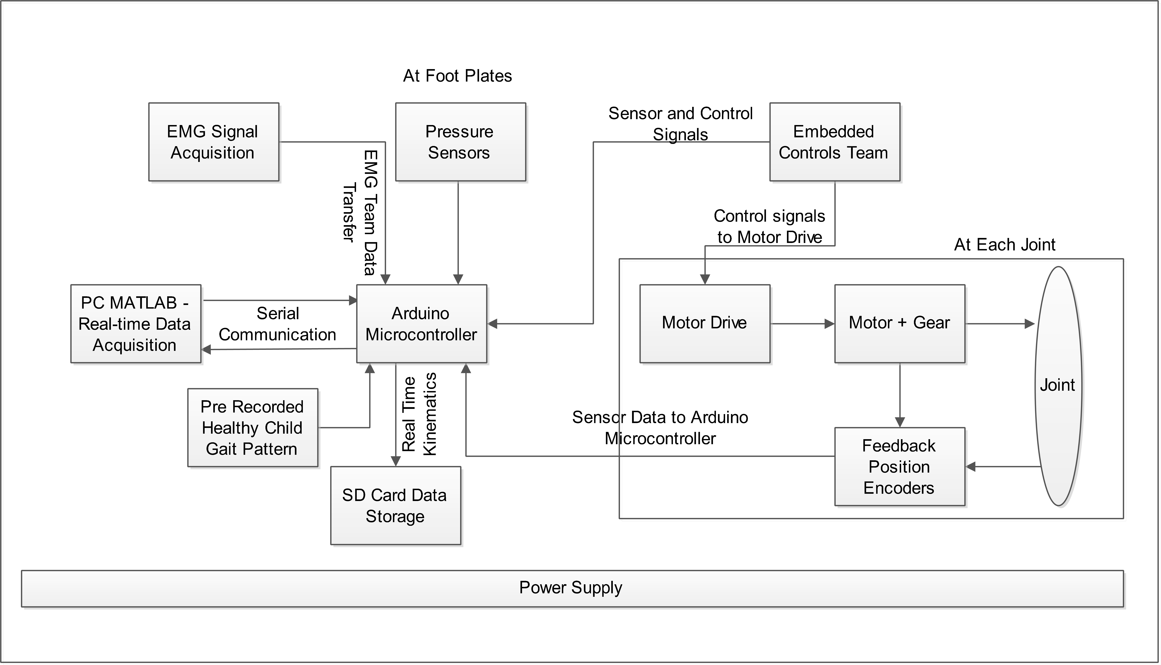

**Figure 3. Flowchart of the overall control and feedback system.**

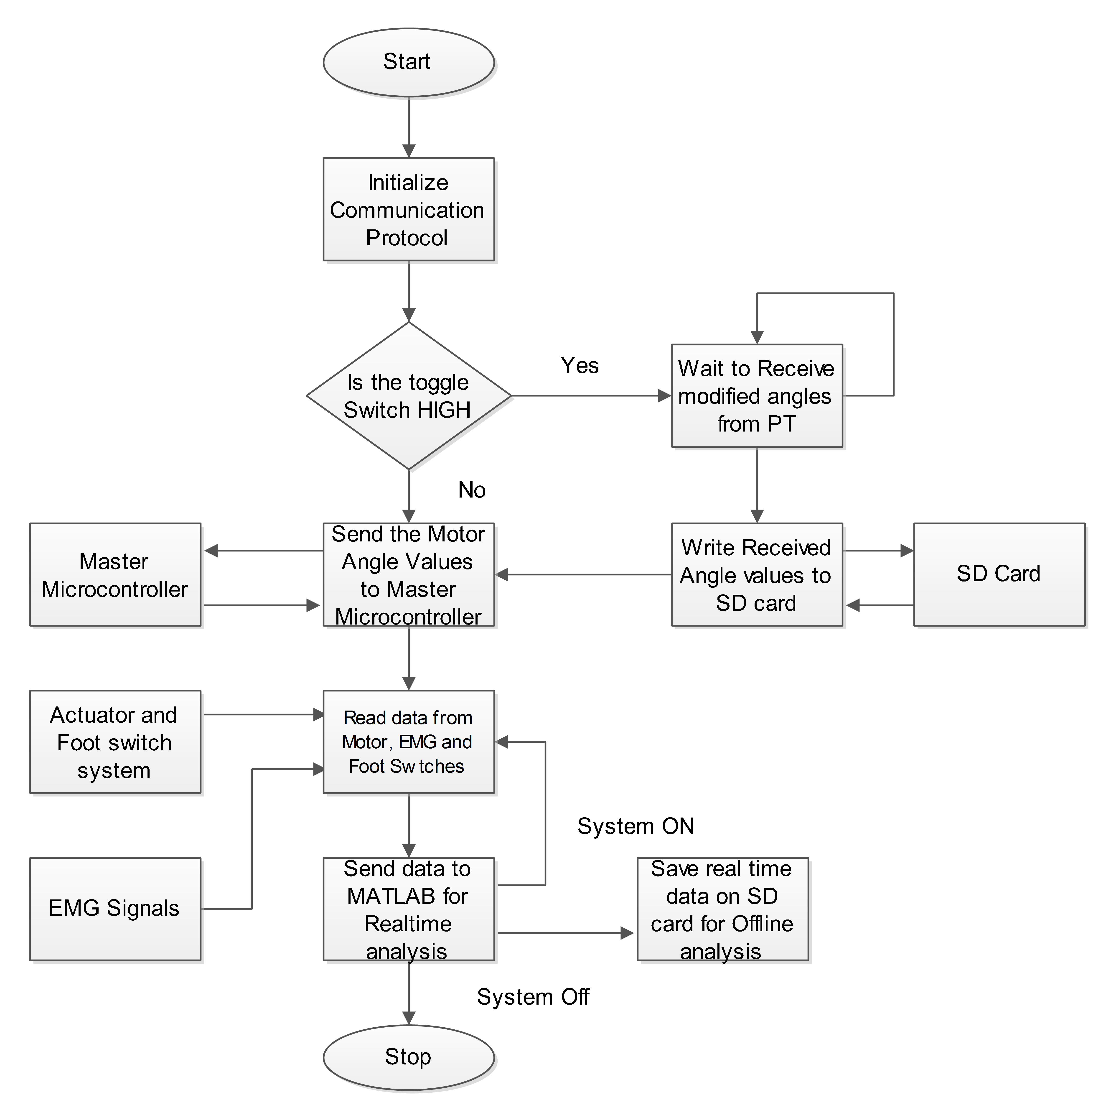

**Figure 4. Arduino program flow**

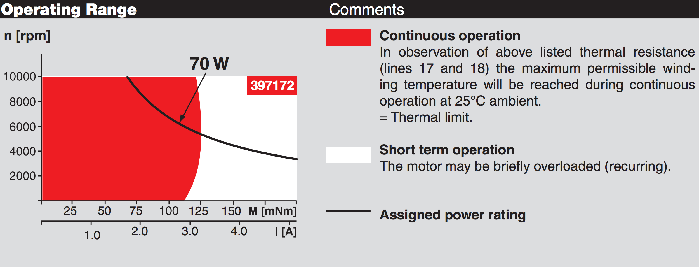

**Figure 5: Operating curves of the Maxon Motor #397172**

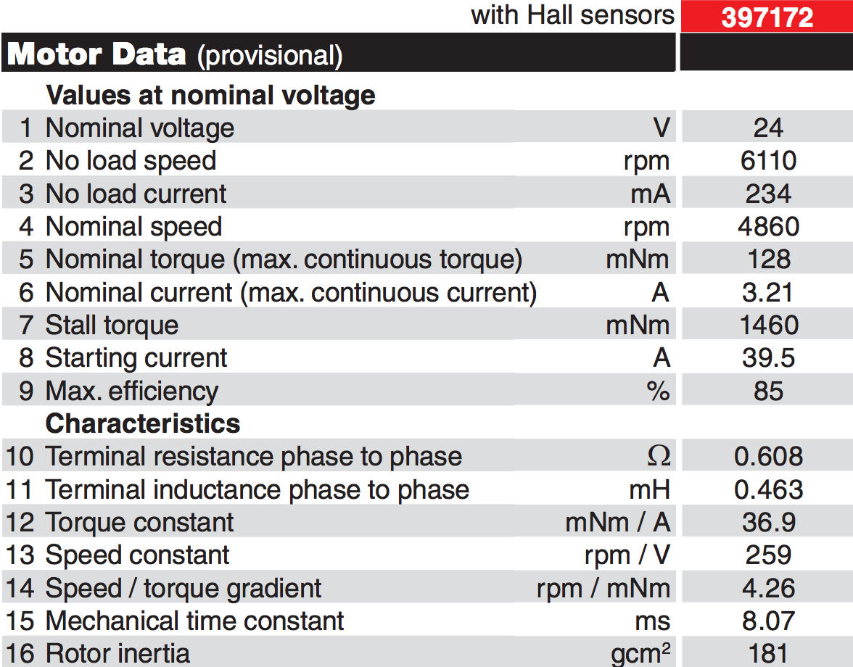

**Figure 6: Technical specification of Maxon Motor Selected #397172.**

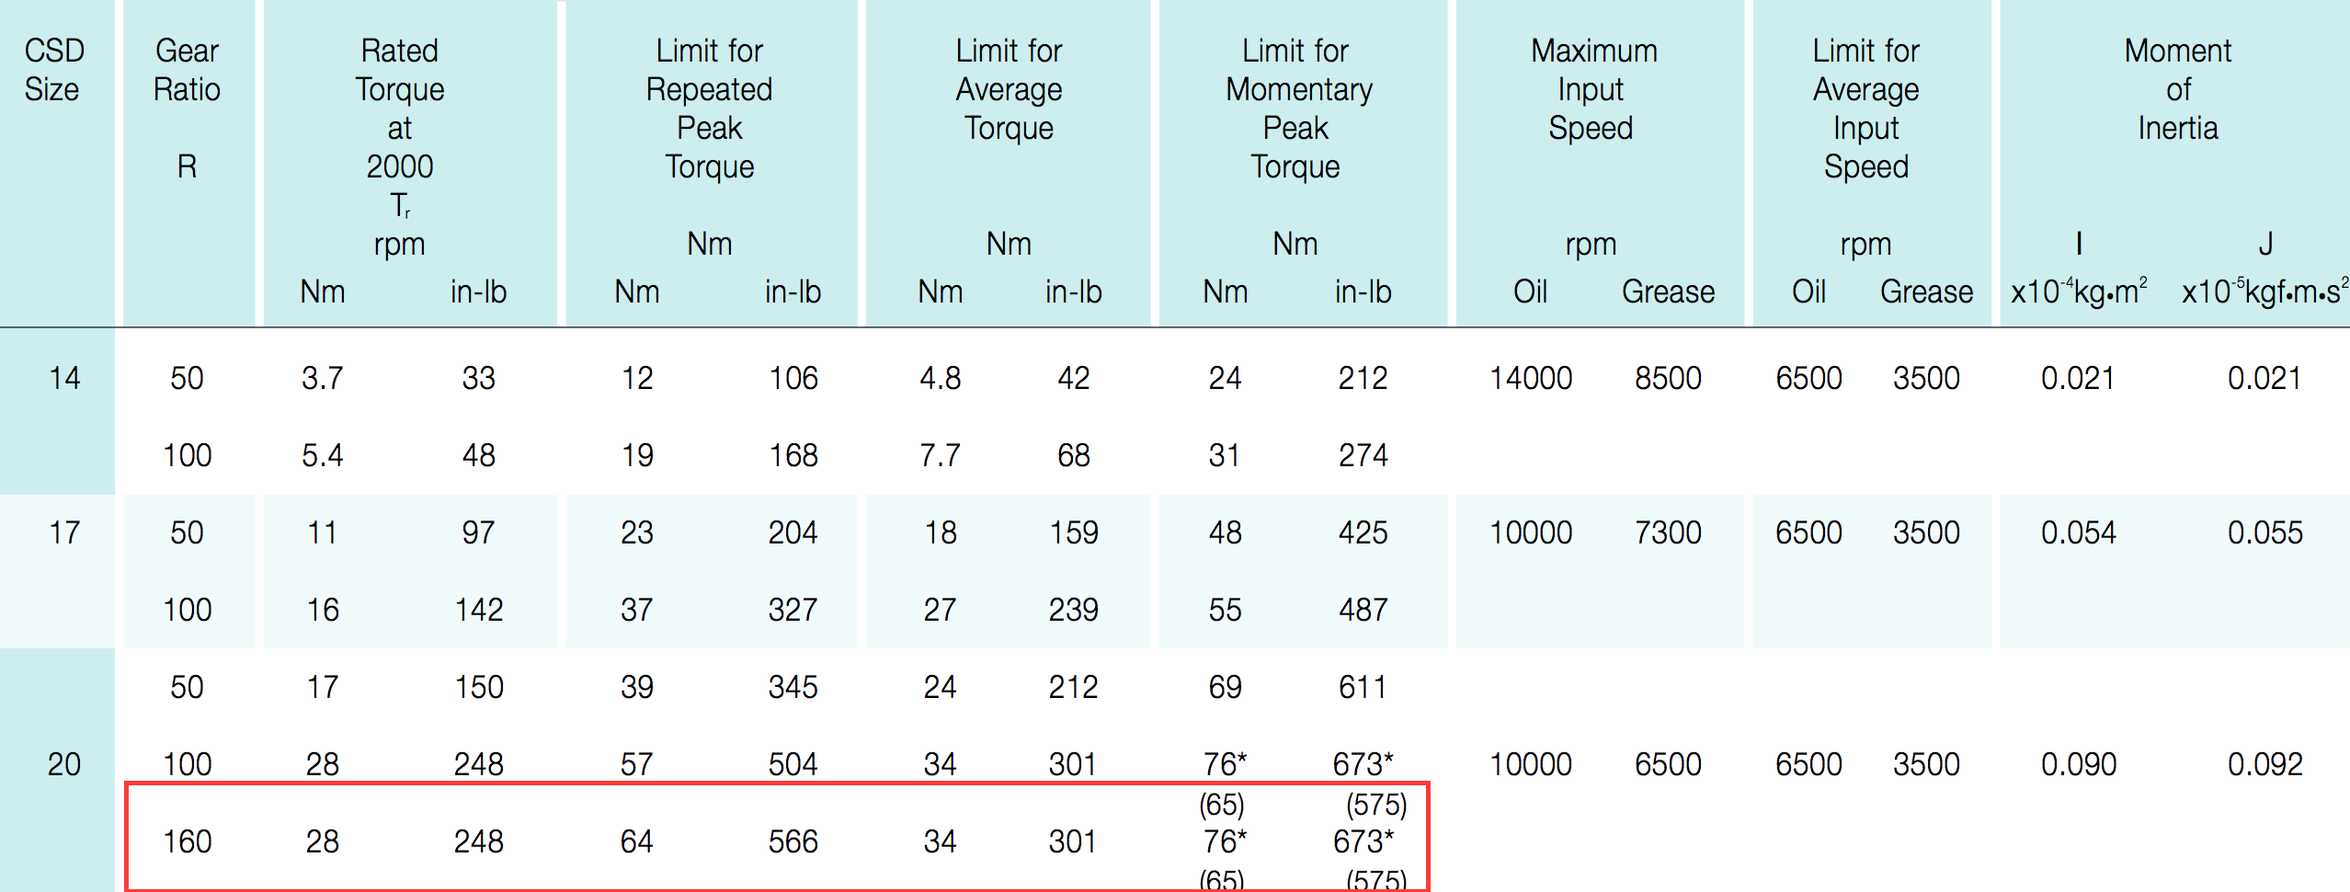

**Figure 7. Harmonic drive selection**

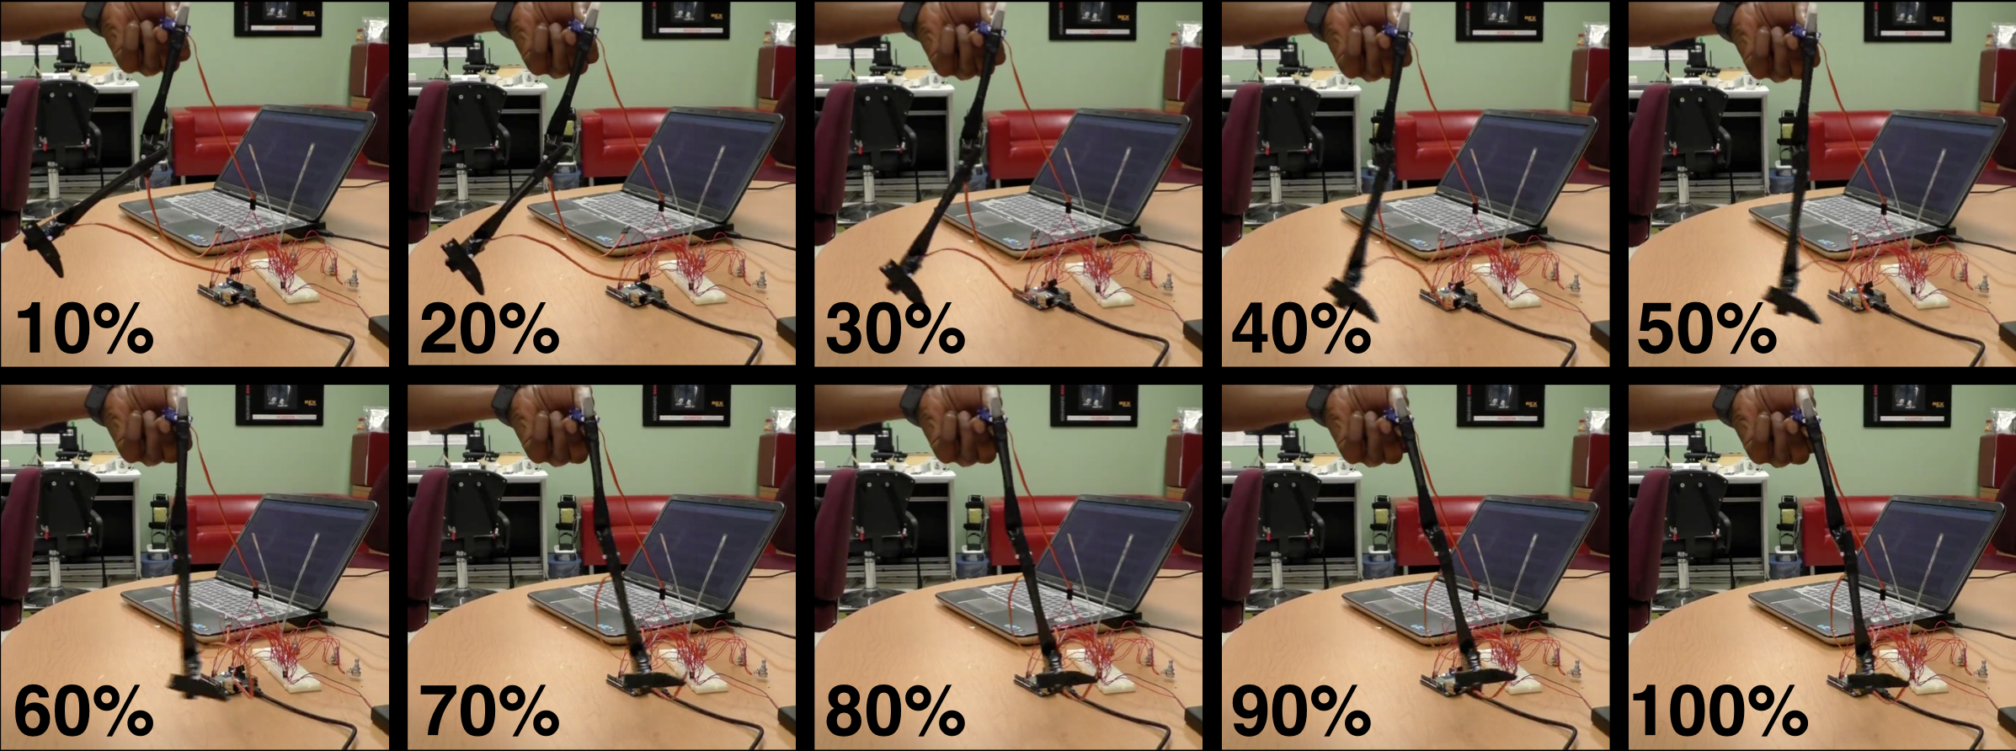

**Figure 8. Position control on scaled down single leg prototype (one step)**

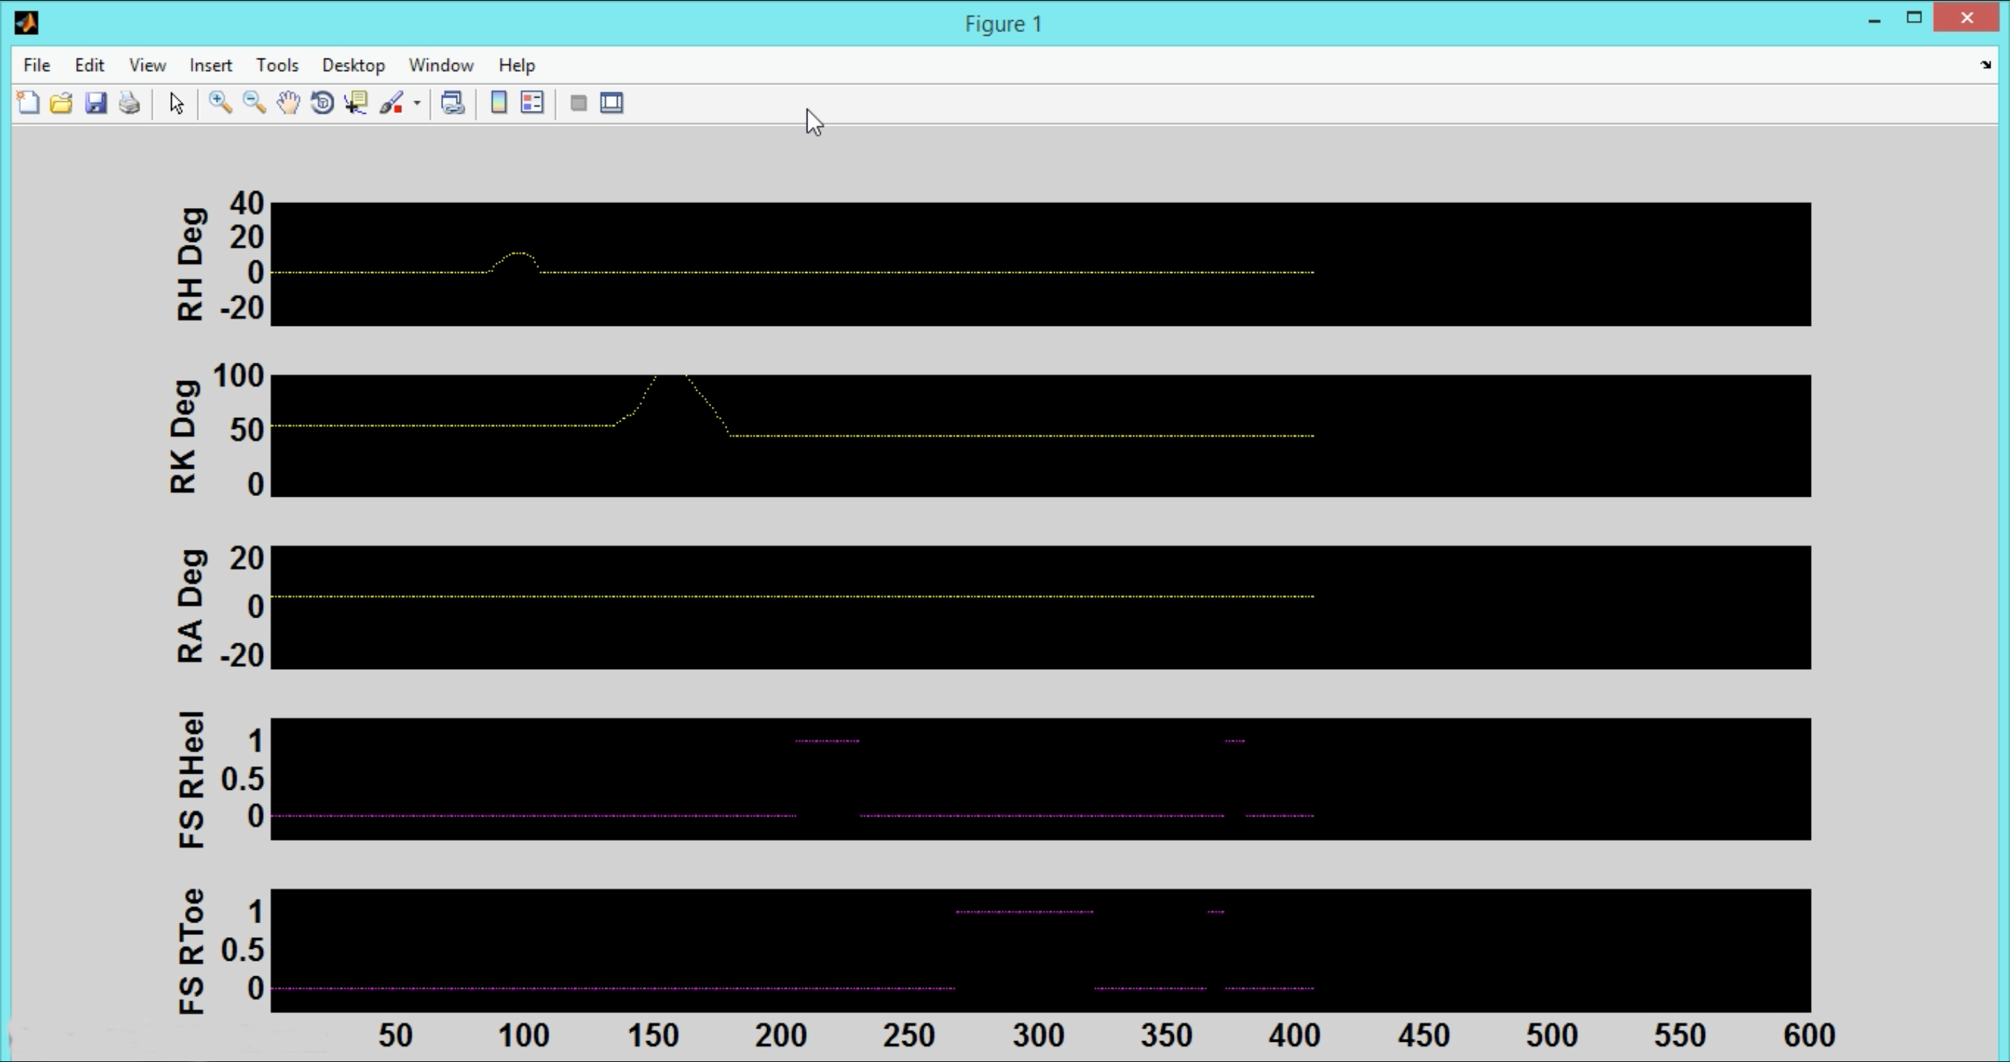

**Figure 9. Real time feedback data monitoring interface**

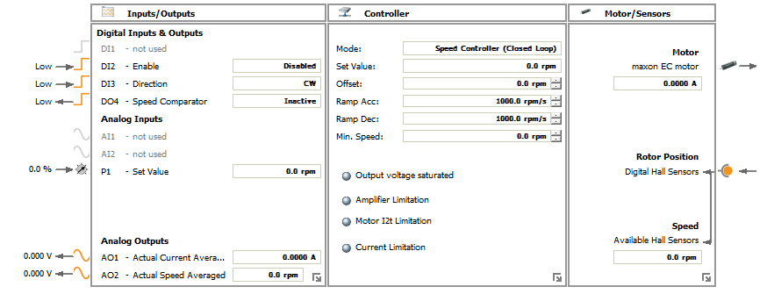

**Figure 10. Block diagram with parameters to the drive for speed control.**

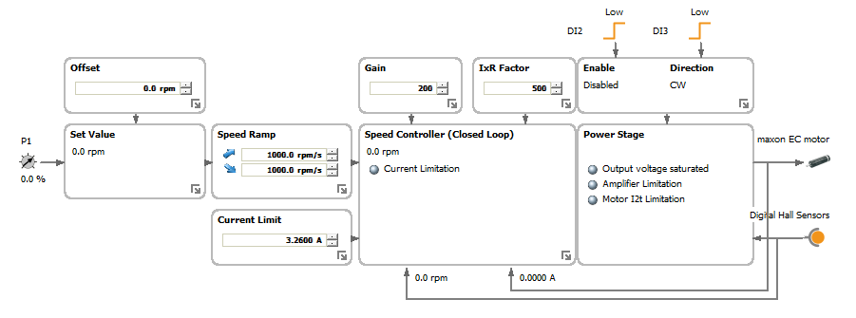 **Figure 11. Flow diagram with parameters to the drive for speed control**

# Tables

**Table 1. Weight of male and female pediatric population**

|  |  |  |  |
| --- | --- | --- | --- |
| **Gender** | **Age** | **Min Weight** | **Max Weight** |
| Male | 4 | 12.5 | 18 |
| 8 | 21 | 35 |
| Female | 4 | 12.5 | 18 |
| 8 | 20.5 | 35.5 |

**Table 2. RPM range need to be maintained during Gait Operation**

|  |  |  |
| --- | --- | --- |
| **Joint** | **Selected rpm** | **Nominal Torque** |
| Hip | 5 - 10 | 13 |
| Knee | 5 - 30 | 13 |
| Ankle | 2 - 20 | 13 |

**Table 3. Power of the motor required to meet torque requirements with losses.**

|  |  |  |  |  |  |
| --- | --- | --- | --- | --- | --- |
| **Joint** | **Max rpm** | **Power in Watts** | **Power (20% Gear Loss)** | **Power (20% Drive Loss)** | **Power (10% Motor Loss)** |
| Hip | 10 | 13.62 | 17.03 | 20.03 | 23.57 |
| Knee | 30 | 40.86 | 51.08 | 60.09 | 70.7 |
| Ankle | 20 | 27.24 | 34.05 | 40.06 | 47.13 |

**Table 4. Linear mapping relationship between motor shaft rotation and the potential output**

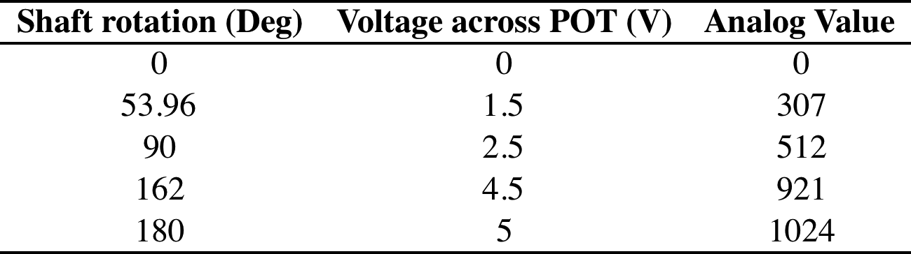

**Table 5: Controlling commands formatting**

